Copyright for test papers and marking guides remains with *West Australian Test Papers*.

The papers may only be reproduced within the purchasing school according to the advertised conditions of sale.

Test papers must be withdrawn after use and stored securely in the school until Wednesday 11th October 2017.

 **HUMAN BIOLOGY**

**Units 3 and 4**

**2017**

**MARKING GUIDE**

**WATP Year 12 ATAR HB Unit 3 and 4**

**Section One – Multiple Choice Questions**

|  |  |  |  |
| --- | --- | --- | --- |
| 1 | D | 16 | A |
| 2 | A | 17 | C |
| 3 | B | 18 | B |
| 4 | C | 19 | A |
| 5 | C | 20 | D |
|  | | | |
| 6 | A | 21 | A |
| 7 | B | 22 | A |
| 8 | C | 23 | C |
| 9 | D | 24 | B |
| 10 | B | 25 | D |
|  | | | |
| 11 | D | 26 | D |
| 12 | C | 27 | C |
| 13 | A | 28 | B |
| 14 | B | 29 | B |
| 15 | C | 30 | D |

**Section Two – Short Questions [100 marks]**

**Question 31 (12 marks)**

1. Complete the table by matching the receptors to the corresponding stimuli. [3]

|  |  |
| --- | --- |
| **Receptors** | **Stimuli** |
| Thermoreceptors | Temperature/heat or cold |
| Osmoreceptors | Osmotic pressure |
| Mechano-receptors (touch) | Pressure, touch, sound |
| Nocireceptors (pain) | Pain, injury, heat or chemicals |

1. Outline the events in the transmission of information from one neurone to another across a synapse. [3]

* When an action potential reaches the synaptic knob, there is opening of Ca2+ gated channels, vesicles containing neurotransmitter fuse with the membrane and is released (in the presynaptic neurone by exocytosis into the synaptic cleft.) [1]
* Neurotransmitters diffuse across the synaptic cleft / gap [1]
* Neurotransmitters bind to the receptor molecules on the post-synaptic neurone, (thereby setting up a new action potential). [1]

1. Explain why hyperpolarisation reduces the likelihood of a new action potential being created. [2]

As the inside of the membrane is more negative than at resting potential, more sodium ions must enter (1) in order to reach the potential difference/ hit threshold for an action potential to be generated (1).

1. The table below compares the number of synapses with the speed of transmission in three neural pathways X, Y and Z. [2]

|  |  |  |
| --- | --- | --- |
| Neural pathway | Number of synapses | Speed of transmission (m/s) |
| X | 12 | 40 |
| Y | 9 | 64 |
| Z | 5 | 89 |

1. Calculate the percentage increase in transmission speed when the number of synapses is reduced from 12 to 9.

Increase in speed 64 – 40 = 24 m/s [1]

Percentage increase 24/40 x 100 =60 % [1]

1. Explain why the neural pathways of reflex arcs have very few synapses. [2]

* Information passes across synapses relatively slowly compared to the speed it passes along an axon. [1]
* The fewer synapses there are, the shorter the overall time taken to respond to a stimulus – an advantage where a rapid response is required. [1]

**Question 32 (10 marks)**

A carpenter pricked his finger on a rusty hook on a broken door. Soon after he noticed that the injured finger was red and swollen. Some time later, he felt a throbbing sensation in his arm. His doctor prescribed a course of antibiotics. Later in the day, he was unwell, running a high fever, broke out in cold sweat and had to take the rest of the day off work. [6]

1. Identify and explain the defence mechanisms used by the body in response to the injury. [4]

* **Inflammatory response** [1]
* The finger becomes inflamed (red and swollen) to allow more blood to flow into area/ **Histamine** also increase blood flow through the area. [1]
* The blood brings more phagocytes to the area to destroy pathogens from the hook. [1]
* The **swelling and pain** reduces movements/ helps confine the pathogens in the area. [1]

1. What are two ways in which antibiotics can act to fight the infection? [2]

* Bactericidal -Kill bacteria by changing the structure of the cell wall or cell membrane or disrupting the action of essential enzymes [1]
* Bacteriostatic - Stop the bacteria from reproducing by disrupting protein synthesis. [1]

1. Describe the thermoregulatory mechanisms that occur during and immediately after a fever. [4]

* Pyrogens/substances in bacteria and viruses signal the hypothalamus to increase your body’s temperature.[1]
* Feels cold / shivering to generate heat; and peripheral blood vessels constrict so skin is pale [1]
* The body temperature will continue to increase until it reaches the new higher set-point of the hypothalamus.[1]
* Once all pathogens are eliminated, fever is broken and shivering stops/

vasodilation and sweating works to cool body back to normal temperature range. [1]

**Question 33 (12 marks)**

According to the WA’s Health Minister John Day and former Federal Health Minister Sussan Ley, the meningococcal outbreaks in Western Australia since early 2016, necessitated a nationwide vaccine program before winter of 2017. Meningococcal disease is a life-threatening disease caused by different strains of the bacterium *Neisseria meningitidis*. Commonly found in the upper respiratory tract (nose, throat and windpipe) of infected people, the bacterium is spread through coughing, sneezing or close contact with infected people, causing blood poisoning and meningitis (inflammation of the membranes around the brain and the spinal cord).

It was also reported that Perth toddler Robbie Buchan lost most of his four limbs after he contracted the B strain of meningococcal. Each injection of the B strain vaccine costs about $150 and babies under one need up to three injections. The B strain vaccine is undergoing a global shortage and limited supplies meant availability would be delayed for a while. While there are more cases of the W strains, there are efforts to make the vaccines for both B and W strains more accessible to the public.

1. Suggest a reason why vaccines are required for all babies at birth, the age of two, four and 6 months. [1]

Mothers’ antibodies do not provide reliable protection / no natural immunity for common virus like Hepatitis B, whooping cough, meningitis etc. [1]

1. Outline the response of B lymphocytes to the meningococcal vaccine. [3]

* Once a B- lymphocyte binds with its specific antigen, it needs to be activated by a helper T cell. [1]
* Once activated, it divides rapidly, producing two types of cloned cells – plasma cells and memory cells [these are clones of the original activated cell that are exact copies]. [1]

(mark will not be given if `antibodies’ is not mentioned).

* Plasma cells produce and secrete huge quantities of antibodies/ while the memory cells keep copy of the shape of the whooping cough pathogen. [1]

1. Explain two ways in which the routine vaccination for meningococcal may cause a decrease in the incidence of the disease in Western Australia. [4]

* Immunisation of an i**ndividua**l provides that person with active immunity. He or she will have a small amount of circulating antibody and memory cells specific to the whooping cough bacteria. [1]
* Secondary response: If the bacterium is encountered again, it is destroyed before the disease symptoms appear. [1]
* Immunisation provides **herd** immunity. Fewer potential suffers mean it is more difficult for the disease to spread. [1]
* Immunisation may reduce the number of unaffected carriers by stimulating their immune system to produce antibodies against the whooping cough bacteria in their respiratory tracts. [1]

1. Why is the B meningococcal vaccine unable to provide protection against other strains of the same bacterium? [2]

* Different strains of the meningococcal bacterium have different surface antigens. [1]
* Antibodies and memory cells produced in response to vaccination are specific to the antigens on the surface of the bacterium. They are ineffective against other antigens. [1]

1. Describe one socio-cultural and one economic factor that influence whether or not parents choose to have their children immunised. [2]

* Economic – cost of visiting a doctor/ cost of the vaccine /priorities of government [1]
* Socio-cultural – perceived health concerns and side effects of vaccine / lack of availability or access to vaccine / ethical or religious objection to medical intervention. [1]

**Question 34 (10 marks)**

Tay-Sachs disease is a disorder of lipid metabolism which occurs as a result of a gene mutation. The recessive allele prevents the gene from producing a protein that will be able to function in the body. These recessive mutations are considered `lethal recessives’, as in the case of the Tay-Sachs disease, lead to the death of the embryo or foetus or the early death of a child.

1. Distinguish between a gene mutation and a chromosomal mutation. [2]

* A gene mutation involves changes in a single gene so that the traits normally produced by the gene are changed or destroyed. [1]
* A chromosomal mutation involves changes in all or part of the chromosome and affect not just one but a number of genes. [1]

1. Explain why Tay-Sachs disease is considered a lethal recessive condition. [2]

* TS is a lethal recessive condition because the recessive allele for TS is not masked by a dominant normal allele. [1]
* The mutant allele is lethal as it brings about a missing enzyme resulting in the accumulation of a fatty substance in the nervous system, bring about an early death. [1]

1. Using examples, explain how a lethal recessive mutation such as the Tay-Sachs disease can bring about changes in the gene pool through the following two evolutionary mechanisms:
2. genetic drift [3]
3. natural selection [3]

Genetic Drift [3]

* TS disease has higher occurrence in Ashkenazi Jews in Eastern Europe [1]
* As a fatal disease, its frequency worldwide is very low but is higher amongst the A Jews because the Jewish population tends to be small and isolated. [1]
* This small and isolated population increases the chance of genetic drift – random, non-directional variation (which explains why a rare allele becomes more frequent in small populations) .[1]

Natural Selection [3]

* While individuals with two normal alleles would be more susceptible to TB, and would possibly die due to TB while individuals with two TS alleles would die early in life. [1]
* Heterozygotes, on the other hand, would have increased resistance to TB and therefore have a survival advantage and would pass their alleles on to the next generation. [1]
* Over time, the gene pool would have more Tay Sachs alleles /frequency of TS allele increases. [1]

**Question 35 (10 marks)**

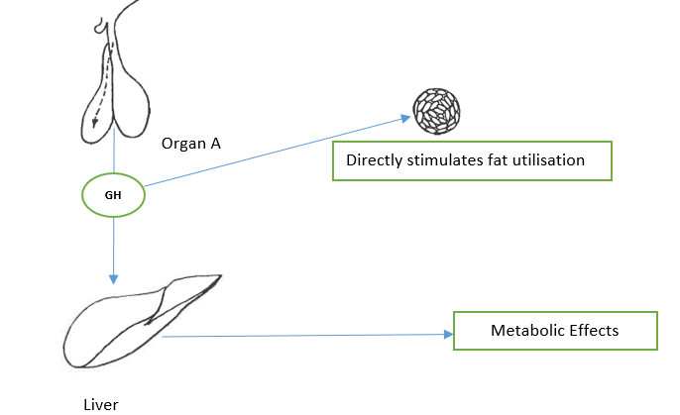

Refer to the diagram above to answer this question.

1. Identify the organ A which releases the growth hormone. [1] Anterior pituitary gland
2. Explain how the two lobes of organ A are different with respect to their relationship with the hypothalamus. [2]

* The anterior pituitary secretes/ inhibits release of hormones in response to releasing or inhibitory factors/hormones from the hypothalamus.[1]
* The posterior pituitary simply stores and releases neuro-hormones that originate in the hypothalamus neurosecretory cells/ under neural stimulation. [1]

1. Describe how growth hormones are released from organ A. [2]

* These **growth hormone releasing factors (GHRF**) from the hypothalamus secreted[1]
* through a **capillary network** which stimulate anterior pituitary gland to release growth hormone (GH) / somatostatin. [1]

1. Describe the metabolic effects of growth hormones. [2]

Growth hormones stimulates the **production of bone cells (chondrocytes)** and development of bone tissue.[1]

Growth hormones stimulates muscle growth through **protein synthesis** (& increased uptake of amino acids and proliferations of myoblasts.) [1]

1. Genetically engineered bacteria have been used to produce human growth hormones through a process called recombinant DNA technology. Outline the steps involved in this process. [3]

* Isolate the human growth hormone using a restriction enzyme and then use the same restriction enzyme to cut open a bacterial plasmid [1]
* Use a DNA ligase to join the insulin gene into the plasmid (forming a recombinant DNA) [1]
* Treat bacteria so that they take up the recombinant DNA (forming a transgenic animal). The bacteria multiplies and produces human growth hormone. [1]

Question 36 (12 marks)

An experiment was carried out with two groups of people. Group A is the control group while Group B

had type 1 diabetes. Every 15 minutes, blood samples were taken from all members of both groups and the mean concentrations of insulin, glucagon and glucose were determined. After each hour, each person was given a glucose drink. All the results of the control group are shown in the graph below. Blood samples were taken every 15 minutes for the next 4 hours.

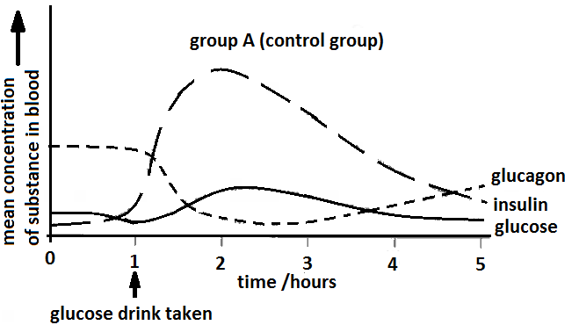

1. Name two hormones, other than insulin and glucagon, that are involved in regulating blood glucose concentration. [2]

Adrenaline [1], glucocorticoids (eg. cortisol) [1]

1. Using the information from the graph above, explain the changes in the blood glucose concentration in group A after drinking the glucose. Refer to the role of insulin and glucagon in regulating blood glucose level on your answer. [6]

* Glucose line on graph rises – glucose concentration rises at first because the glucose that is drunk is absorbed into the blood. [1]
* This rise in blood glucose cause insulin to be secreted from the beta-cells of the pancreas and insulin line rises steeply.[1]
* Insulin causes increased glucose uptake of glucose into the liver and muscle cells/ activating enzymes to convert glucose into glycogen /and fat (glycogenesis), and also increases cellular respiration.[1]
* The effect of all these actions is to reduce blood glucose concentration / glucose line falls from 2.5 hours onwards.[1]
* As the glucose concentration rises after 1 hour, so the glucagon level falls. This drop in glucagon decreases glucose production from other sources (glycogen, amino acids and glycerol) and also helps to reduce the blood glucose concentration.[1]
* As the BGL falls (after 3.5 hours), so the glucagon concentration increases to help maintain the BGL at the optimum concentration.[1]

1. On the graph given below, sketch a curve on it to show what you would expect the mean concentration of the glucose, insulin and glucagon results of the members of Group B to be. [3]

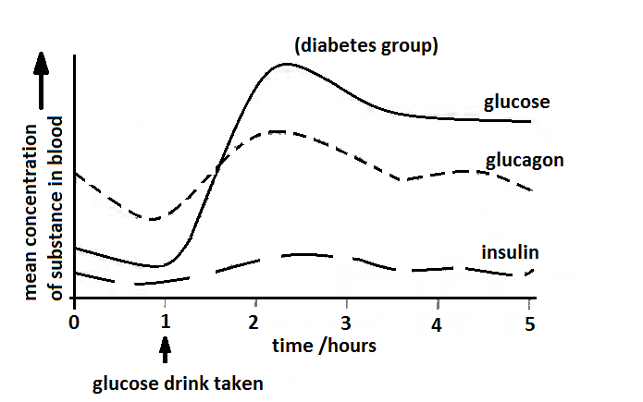

1. Suggest what might happen to the blood glucose concentration of Group B if they have no food for over the next 24 hours. [1]

As glucose is respired by cells, the glucose concentration will decrease steadily until it falls below the optimum concentration. [1]

**Question 37 (14 marks)**

Zika virus (ZIKV) is responsible for major unprecedented outbreaks and epidemics, and has been causally associated with feta microcephaly. The development of a safe and effective ZIKV vaccine is now an urgent global health priority. The following experiment shows the use of a type of vaccine that protect against ZIKV in rhesus monkeys. A purified inactivated virus vaccine VRC 5288 induced ZIKV-specific neutralizing antibodies and completely protected monkeys against ZIKV strains from both Brazil and Puerto Rico.

Before the clinical development of ZIKV vaccines, the following investigation is to determine the relationship between the number of correct dosage of the ZIKV vaccine and its effectiveness to produce an immune response or immunogenicity. Immunogenicity is measured by the amount of neutralizing antibodies (Ab) produced.

Method:

1. There are four groups of six monkeys (specifically Rhesus macaques).
2. Group A received a single 1 mg dose of VRC 5288 at week 0.
3. Group B received a single 1 mg dose of VRC 5288 at week 0 and another 1 mg dose of VRC 5288 at Week 4.
4. Group C received a single 4 mg dose of VRC 5288 at week 0 and another 4 mg dose of VRC 5288 at Week 4.
5. Group D is the control group.
6. Every week, the monkeys’ sera were assayed by ELISA [Enzyme Linked Immunosorbent Assay] for ZIKV neutralising antibodies (Ab). The average Ab concentration for each group is given in Table 1.

Eight weeks after immunisation, all groups of animals were challenged subcutaneously with a ZKRV strain from Puerto Rico PRVABC 59. Blood sample was collected daily for polymerase chain reaction (PCR) analysis of the ZIKV genome copies in plasma to determine virus load (viremic level).

TABLE 1

|  |  |  |  |  |
| --- | --- | --- | --- | --- |
|  | Average Antibody concentration – arbitrary units/ genome copies per mL | | | |
|  | Group A  VRC 1 mg x 1 | Group B  VRC 1 mg x 2 | Group C  VRC 4 mg x 2 | Group D |
| Week 0 | 0 | 0 | 0 | 0 |
| Week 1 | 0 | 0 | 0 | 0 |
| Week 2 | 2.00 | 2.50 | 2.75 | 0 |
| Week 3 | 3.25 | 3.50 | 3.75 | 0 |
| Week 4 | 3.50 | 3.75 | 4.25 | 0 |
| Week 5 | 3.75 | 4.00 | 4.50 | 0 |
| Week 6 | 3.50 | 4.25 | 4.75 | 0 |
| Week 7 | 3.25 | 4.50 | 5.00 | 0 |
| Week 8 | 3.00 | 4.25 | 4.75 | 0 |
| Viremic Level  (Presence of virus in the blood) after challenge | High  +++ | Negligible  - | Negligible  - | Very High  +++++ |

1. Based on the data given in Table 1, plot a graph to show the relationship between the average antibody concentrations for each group over an eight-week post vaccination. [6]

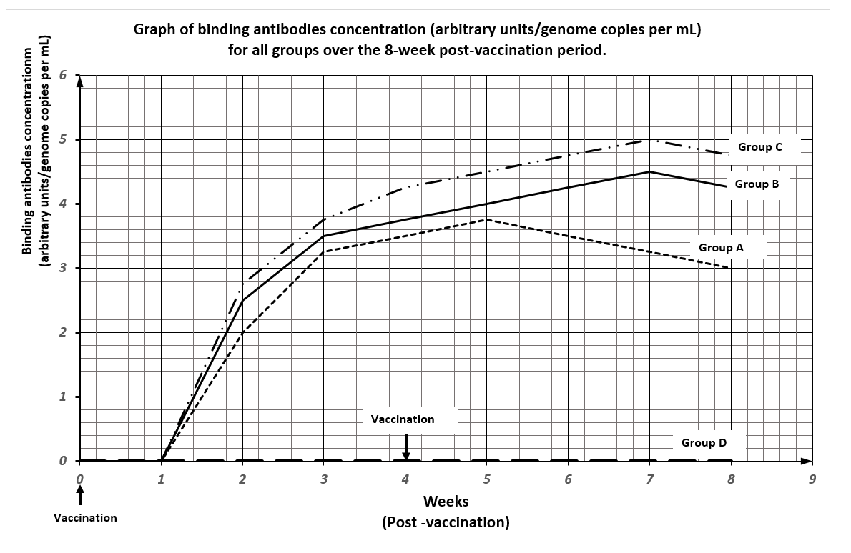

Graph Grid

|  |  |
| --- | --- |
| 1 mark | Title (relating the independent and dependent variables) |
| 1 mark | Correctly labelled x axis with units |
| 1 mark | Correctly labelled y axis with units |
| 1 mark | Suitable scale |
| 1 mark | Legend/Key |
| 1 mark | Accurate plotting |

1. Describe a control group (Group D) that could be used for this experiment. [1]

Group D received a control vector (empty backbone plasmid) at week 0 /

placebo injection

1. State one factor involving the monkey’s serum in monkeys that the scientists would have to determine before they begin the experiment. [1]

Scientists need to establish the initial level of neutralizing antibodies in the monkey’s serum (specific to the flavi-virus (strain specific to ZIKV) at the start of the experiment.

1. Describe the immunogenic responses of the groups being investigated. [2]

All ZKV vaccine groups had significantly higher antibodies responses than the control Group D.[1]

Monkeys that received a single dose of 1 mg of VRC5288 had significantly lower antibodies than macaques that receive two doses of vaccine.

1. What could be the conclusion of this investigation? [1]

* Monkeys that received two 4 mg doses or 1mg doses of VRC 5288 were largely protected from the Zika virus. It is essential that monkeys receive two doses (Week 0 and Week 4) for full efficacy. [1]

[All monkeys in Group A receiving the 1-mg dose of BRC 5288 at week 0 were

viremic.]

1. What further investigation is needed before the VRC 5288 can be evaluated in human trials? [1]

* Investigate with a wider, dynamic range of the dosage/assay to allow for a more precise definition of the protective threshold needed to prevent viremia
* Investigate and increase understanding of ZIKV viral replication patterns in monkeys (non-human primates) and in humans to determine full efficacy of vaccines.
* Or any suitable answer given 1 mark.

1. Scientists in this investigation are now working on evaluating both protein-based, wholly inactivated ZIKV vaccine and live-attenuated vaccine approaches. Explain the difference between these two vaccine approaches. [2]

* Whole, inactivated vaccines – contain complete **non-virulent** micro-organisms (that are killed) inactivated with formalin or chemicals.[1]
* Live-attenuated vaccines – utilises live micro-organisms with **reduced virulence** – that is with a reduced ability to produce disease symptoms, so that the immunised person does not contract the disease but makes antibodies against the antigens.[1]

**Question 38 (10 marks)**

Refer to the following table to answer the question.

Table 2 : Relationship between humans and great apes using DNA differences

|  |  |
| --- | --- |
| Primates being compared | DNA difference (%) |
| Human - chimpanzee | 1.2 |
| Chimpanzee - gorilla | 1.2 |
| Human - gorilla | 1.6 |
| Chimpanzee - orang utan | 1.9 |
| Human - orang utan | 2.5 |
| Gorilla - orang utan | 2.5 |

1. Use the information given in the table above to construct a phylogenetic tree to illustrate the evolutionary relationships of the great apes and humans. [3]

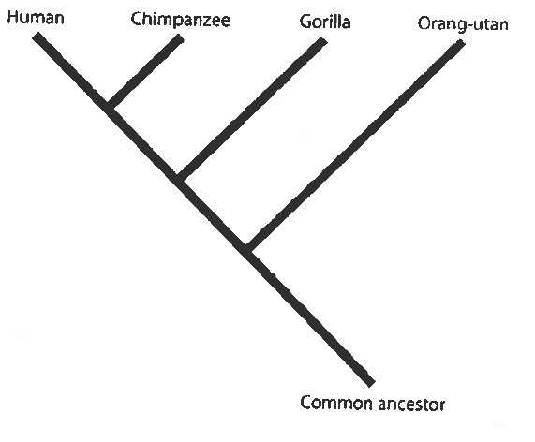

* 1 mark for indicating three species in the right order.
* 2 marks for indicating four species in the right order.
* Full marks for indicating all species in the right order using an appropriate phylogenetic tree format. (Distance between the species is not that critical.)

1. The drawings show some stone tools. A1 and A2 belong to a different tool culture from B1 and B2.

B2

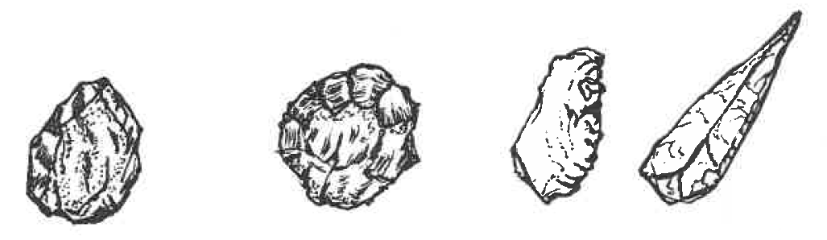

B1

A2

A1

1. Identify the tool culture of B1 and B2. [1]

Mousterian Tool Culture (France) [1]

1. Give two pieces of evidence to suggest that A1 and A2 are older than tools B1 and B2. [2]

A1 and A2 – simple stone tools, sharp flakes observed made by hitting with a rock [1] / larger flakes removed/ few flakes removed

B1 and B2 – more refined, using stones, bone/antler / flint / whole tool shaped [1]

1. Suggest two possible uses of tools such as A1 and A2.[2]

Chopper for cutting meat or cracking bones to obtain marrow [1]

Scraper to remove waste materials / clean animal hides [1]

1. Describe how tools B1 and B2 might have been made. [2]

* Stone flakes are made by breaking flakes off a stone core
* Use of a softer hammer of bone or antler to refine the flake
* Pressure flaking to sharpen knife edge

(any 2 of the above or suitable answers to obtain 2 marks)

**Question 39 (10 marks)**

The images show front, side and bottom views of the skull of an Australopithecine.

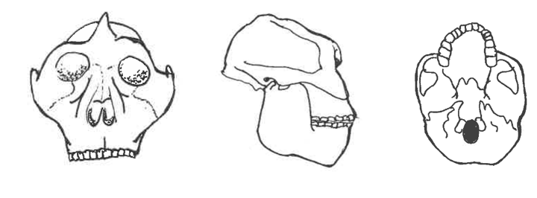

1. Describe how an examination of the skull as shown above could give evidence about the posture, locomotion, brain size and diet of an Australopithecine. [4]

* Front view – Posture - Presence of the zygomatic arch and nuchal crest for muscle attachment suggests presence of robust jaw muscles and neck muscles to hold up a forward-heavy face – **posture – stooped**. Almost erect stance
* Side view – Locomotion - shows a nearly central position of foramen magnum would indicate an upright stance and **bipedalism.**
* Side view & front view – Brain Size - indicates a cephalic index which indicates relatively small cranial capacity/ **brain size** (cf to modern humans).
* Side view – Diet - Presence of robust malar bone and massive jaws (high degree of prognathism) suggests a diet that comprises **tough fibrous food.**

[Side view & front view – suggest parabolic dental arcade and teeth that permit grinding movements and for chewing]

1. Compare the posture and brain size of an Australopithecine and a gorilla. State the differences between the early hominid and the great ape. [2]

|  |  |  |
| --- | --- | --- |
|  | **Australopithecine** | **Gorilla** |
| **Posture**  **(both correct to obtain 1 mark)** | erect | Quadrupedal |
| **Brain Size**  **(both correct to obtain 1 mark)** | 440 – 480 cc | About 450 cc |

1. i. The Laetoli footprints (a set of footprints) found in volcanic ash in Tanzania are 3.56 million years old and are believed to have been made by *Australopithecus afarensis*. Outline two methods by which it would be possible to determine how long ago the Australopithecine lived. [2]

Potassium-argon dating (1)

Analysis of stratigraphy (1)

1. State the assumptions that must be made using these two methods of dating. [2]

* The use of potassium-argon dating relies on suitable material such as volcanic lava, being present/ rocks of similar age/ covered in lava. [1]
* Layers laid down in the order they appear/ layers further down are older/ at the top are younger/ layers in different areas with similar layers are of the same age. [1]

**Section Three - Extended answer [40 marks]**

**Question 40 (20 marks)**

One of the most exciting discoveries in recent years is the fossil skeleton of a new species, *Homo floresiensis,* found in the Liang Bua Cave on the Island of Flores in Indonesia by Australian and Indonesian palaeontologists. The discovery was announced to the world in 2004, and the fossil nick-named `the hobbit’ lived as recently as 18 000 years ago until a massive volcanic eruption decimated them. The fossil skeleton stands only one metre tall and has a small brain size of 380 cm³. It was found with stone tools and the remains of pygmy form of extinct elephants *Stegodon* and burnt remains of smaller animals.

1. Describe the physical features of this fossil skeleton that would place it in the genus `*Homo*’. Also identify any discovered features that challenge our understanding of the evolution of the genus `*Homo*’. [8]

|  |  |
| --- | --- |
| Physical Features of `Homo’ - *at least 2 features of bipedalism to be mentioned* | 6 |
| Relatively lightly boned (less robust)  Reduced jaw size  Reduced prognathic face  Reduced canine teeth  **Features indicating bipedalism (central positioning of foramen magnum of the skull/ S-shaped spine/ broad pelvis, foot arches – transverse & longitudinal)** |  |
| Challenges (any 2) | 2 |
| Small brain of 380 cc – other homo species 0 > 800 cc [1]  Cooking/tools present which suggests advanced culture not expected of 380 cc brain size. [1] |  |

1. What evidence and techniques could be used to indicate this fossil skeleton may be related to *Homo erectus*? [4]

|  |  |
| --- | --- |
| Evidence | 2 |
| same location of origin H erectus arrived in South East Asia some 60 000 years ago.  use of fire (which characterised *H erectus*) |  |
| Techniques | 2 |
| DNA testing / use of mitochondrial DNA and comparative genomics / employ use of PCR and GE for DNA testing [1]  Radio-carbon dating & other radiometric dating methods useful for cave sites [1] |  |

1. Fossils included the genus `Homo’ are described as `gracile’ hominins. Describe how the `*Homo*’ genus are different from the *Australopithecines.* [8]

|  |  |
| --- | --- |
|  |  |
| ***Homo*** (any 4 of the following) | 4 |
| * Taller and larger in stature * relatively large brain capacity * no sagittal crest * less heavy-boned than Australopithecines * reduced jaw size and * made and use tools |  |
| ***Australopithecines*** (corresponds to each of the 4 of the following) | 4 |
| * smaller in size * relatively smaller brain-case * sagittal crest in some forms * forward projecting face (shows distinct prognathism) * more robust body form |  |

**Question 41 (20 marks)**

1. A minute sample of DNA has been obtained from an individual for paternity testing and to establish any possible link with a rare genetic disorder.
2. Outline two **named** techniques in biotechnology that are carried out before proceeding to DNA sequencing of the genome.
3. Rapid developments in genomic testing methods have made the sequencing of a person’s DNA faster and cost-efficient. List the ethical issues involved in the use of the genomic information as a `lifetime health resource’. [14]

|  |  |
| --- | --- |
| Polymerase Chain Reaction - named | 1 |
| Denaturation – double-stranded DNA is separated into single strands by heating to 96° C.  Annealing – use of Taq polymerase, primers, free nucleotides to complete DNA replication whilst cooled to 72°C.  Elongation– Process is repeated with newly formed DNA strands – thermos-cycling of heating and cooling to produce 2ⁿ copies for n cycles.  End result – Amplification of DNA | 4 |
| Gel Electrophoresis - named | 1 |
| DNA is cut by restriction enzymes to fragments of varying size (kilobases)  DNA is micro-pipetted into wells on a gel plate & subject to an electric current in a GE cell  Being negatively charged, DNA moved towards the positive electrode  Shorter, lighter DNA fragments travel faster than the longer, heavier DNA fragments.  A pattern of DNA bands can be detected when DNA treated with chemicals fluoresce under ultra violet light and photographed to show the DNA profile. | 5 |
| Ethical Issues (any 3 or suitable responses) | 3 |
| Genetic information is hereditary so knowledge of an individual’s own genome has implications for members of the family  Legislation is needed to ensure that there is no discrimination on the basis of genetic information  Genetic procedures as such are still costly – not accessible to all -, and there is no easy answer as to who should pay for them.  Our ability to interpret genomic information is still at an early stage. Even for those whom we know, with certainty, have a genetic condition, it can be challenging to identify a specific disease-causing gene change. We do carry many different types of genetic variants. So genomic testing can lead to incorrect or over-diagnosis.  Genomic information has the potential to influence the direction of human evolution because human intervention determines which embryos to implant and which to discard after identifying the genome. Sometimes the stem cells of healthy embryos are used as donor cells to generate tissue to treat individuals with genetic abnormalities.  When this occurs, the affected individual, who might otherwise die, may lead a relatively healthy life, even reaching reproductive age—then the defective alleles may be passed on to offspring and the genetic disorder is perpetuated.  Other issues surround the privacy and disclosure of genetic information and the storage or future use of test samples and data etc |  |

1. Define cell replacement therapy and gene therapy. For each of these techniques, give an example of its application and state any ethical concerns raised by each of this kind of human intervention. [6]
2. **Gene therapy [3]**

|  |  |
| --- | --- |
| Definition | 1 |
| **Gene therapy** is the inserting of the normal (healthy gene) for a faulty gene to bypass its effects. [1] |  |
| Application | 1 |
| It works well with single gene disorders such as cystic fibrosis/ Huntington Disease/ muscular dystrophy / sickle cell anaemia. [1] |  |
| Ethical Issue(s) | 1 |
| While gene therapy is used to treat a patient, it also raises some ethical issues. It does not alter the genotype of the affected individual, who can still pass the defective gene on to offspring, thereby perpetuating the genetic disease in the population.  Viruses are typically used as the vector or delivery system for delivering the gene in gene therapy to the affected tissue in a patient—however, there is no guarantee that the virus used will not itself be the subject of a defense response by the body’s immune system. There may be unforeseen side-effects resulting from gene therapy.  Unknown long term effects on individuals and on subsequent generations |  |

1. **Cell replacement therapy** [**3]**

|  |  |
| --- | --- |
| Definition | 1 |
| Cell replacement therapy is a treatment which made use of cell culturing to replace damaged cells with healthy ones.[1] |  |
| Application | 1 |
| EXAMPLE – Cell replacement therapy for the nervous system is used to treat neurodegenerative disorders such as Parkinson’s / Alzheimer’s. [1] |  |
| Ethical Issue(s) | 1 |
| Use of embryonic stem cells is controversial and raises a number of ethical questions  -long term effects to be explored  - cost and affordability – not accessible to all – who pays?  - moral issue of using `embryos’ tantamount to taking `life’ |  |

**Question 42 (20 marks)**

1. The Rotary Beachside Festival Fun Run in Safety Bay, Rockingham WA on 26 March 2017 was scheduled to start in the morning at 9 am. The Fun Run was to be a 21 km half marathon or10 km or 5 km fun run, and the competitors have 4 hours to finish the event. The event organizers took into account the expected weather conditions when scheduling this event to allow the athletes to perform in the most suitable conditions.

The expected weather conditions were as follows:

* mean maximum daily temperature: 23.4oC
* mean 9 am temperature: 16.9 oC
* mean 9 am humidity: 62%
* mean 3 pm temperature: 22.7 oC
* mean 3 pm humidity: 52%

During this event, the athletes need to maintain their homeostasis of body temperature and body fluid concentrations. Outline these two homeostatic mechanisms and the interactions between them in an athlete participating in this event during the given expected weather conditions for March in Rockingham, WA. **[12]**

|  |  |
| --- | --- |
| Thermoregulation | 6 |
| * Gain of heat directly from the environment through radiation and conduction as well as heavy exercise * Rise in skin or core body temperature (stimulus) detected by the thermoreceptors 🡪 hypothalamus * Hypothalamus co-ordinates responses that increases heat loss through the parasympathetic nerves of the autonomic nervous system * Sweating increases (sweat cools by evaporation); will become more profuse with rising humidity * Blood flow to skin (vasodilation) increases to increase heat loss * Negative feedback to restore body temperature to normal |  |
| Body Fluid Regulation | 6 |
| * Water concentration of blood plasma decreases/ osmotic pressure of blood increases; mouth becomes dry * Osmoreceptors in the thirst centre of the hypothalamus are stimulated, * Creating sensation of thirst * Person responds by drinking water / cooling liquids * Water drunk is absorbed into the blood from the alimentary canal system * Water leaves the blood, the intercellular fluid and extracellular fluids return to normal concentrations * Increase ADH production, more water reabsorbed in the kidney nephrons to replace water loss |  |

* Must include thirst reflex and behavioural response

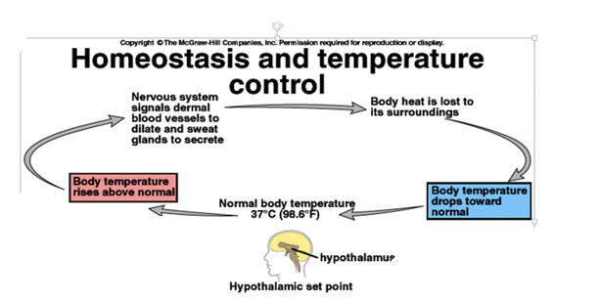

1. Using hyperthyroidism as an example, discuss how a chronic disease can occur when there is a disruption of homeostasis in the body, including how it can be treated or controlled. [8]

|  |  |
| --- | --- |
| Statement of how a disruption can occur  Identify a named disruption  Explanation of the particular homeostatic mechanism that has broken down or failed and a reason why it has caused the disease | 4 |
| Cause, symptoms and treatment | 4 |
| Chronic disease can occur when there is a disruption of homeostasis in the body because such malfunctions lead to imbalances and a subsequent oversupply or undersupply of substances needed by the cells. [1]  Grave’s disease is an example of hyperthyroidism. [1]  In patients with Graves’ disease, the thyroid gland is enlarged caused by an immune system reaction. [cause] [1]  The cells are overstimulated as the immune system makes thyroid stimulating immunoglobulin (TSI), [1]  which is an antibody that mimics TSH, stimulating the thyroid to make more T3 and T4 hormones than the body needs. {oversupply} [1]  The hypersecretion of thyroid hormones leads to a range of problems, such as increased heart rate, weight loss, increased appetite, fatigue, sweating, anxiety and in the case of Grave’s disease, protruding eyeball. {symptoms} [2] (at least two symptoms mentioned)  This can be treated with drugs that block the gland’s use of iodine/ by surgery to remove some or part of the gland. [1]  Drinking radioactive iodine can kill some of the thyroid cells. [1] |  |